**Additional Technologies are needed for the Full Stack Java Developer course.**

Due to time restrictions, we won't cover some technologies we will use in this course. We highly recommend learning these technologies in your free time as they are straightforward but require some time to study and practice. We will need this knowledge in the Spring Framework module (the second module of this course) as we will start building websites and accessing a MySQL database.

The following is the list of technologies required. Each list’s point links to a tutorial where we can learn the technology.

1. HTML – Stands for HyperText Markup Language. It is the standard markup language to build Web pages. With HTML, you can create your Website.
   1. <https://www.w3schools.com/html/default.asp>
   2. If you have more time available, study all the topics in this HTML tutorial.

| Study all the topics from HTML Home to HTML Lists in the menu of the tutorial. | Also, check all the topics in the HMTL Forms Section in the menu. |
| --- | --- |
|  |  |

1. CSS – Stands for Cascade Style Sheet. It is the language we use to style an HTML document. It describes how the browser should display HTML elements, for instance, colours, fonts, sizes, etc.
   1. <https://www.w3schools.com/css/default.asp>
   2. Study all the topics from *CSS Home* to *CSS Lists* in the right menu of the tutorial.

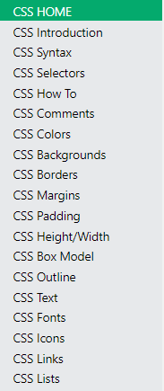

* 1. If you have more time available, study all the topics in the CSS tutorial.

1. Bootstrap – It is an HTML, CSS, and JavaScript framework for developing responsive websites.
   1. <https://www.w3schools.com/bootstrap4/default.asp>
   2. If you have more time available, study all the topics in this Bootstrap tutorial.

| Study all the topics from *BS4 Home* to *BS4 Tooltip* in the right menu of the tutorial. | Also, check all the topics in the HMTL Forms Section in the menu. |
| --- | --- |
|  |  |

1. SQL – Stands for Structured Query Language. It is the standard language for storing, manipulating and retrieving data in relational databases such as MySQL, SQL Server, Oracle, Sybase, Informix, Postgres, and other database systems.
   1. https://www.w3schools.com/sql/default.asp
   2. Study all the topics from SQL Home to SQL Aliases in the right menu of the tutorial.

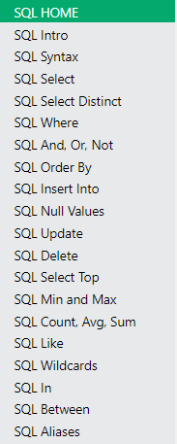

* 1. If you have more time available, study all the topics in the SQL tutorial.

// End